Lab – Determining the IP Address Configuration of a Computer

1. Objectives

In this lab, you will configure an Ethernet NIC to use DHCP to obtain an IP address and test connectivity between 2 computers.

1. Required Resources

* 1 Wireless router
* 2 PCs (Windows 10)
* Ethernet cables
  + 1. Connect PC-A and PC-B to a home/small business wireless router.
       1. For PC-A, plug one end of the Ethernet cable into “Port 1” on the back of the wireless router.
       2. For PC-A, plug the other end of the Ethernet cable into the network port on the NIC in your computer.
       3. For PC-B, plug one end of the Ethernet cable into “Port 2” on the back of the router.
       4. For PC-B, plug the other end of the Ethernet cable into the network port on the NIC in your computer.
       5. Power on the wireless router.
       6. Turn on both computers and log on to Windows in PC-A using an account with administrative privileges.
    2. Set network settings to autoconfigure using DHCP
       1. Click **Start**, then click **Settings**.

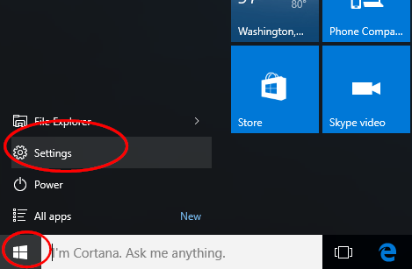

* + - 1. In the Settings window click **Network & Internet**.

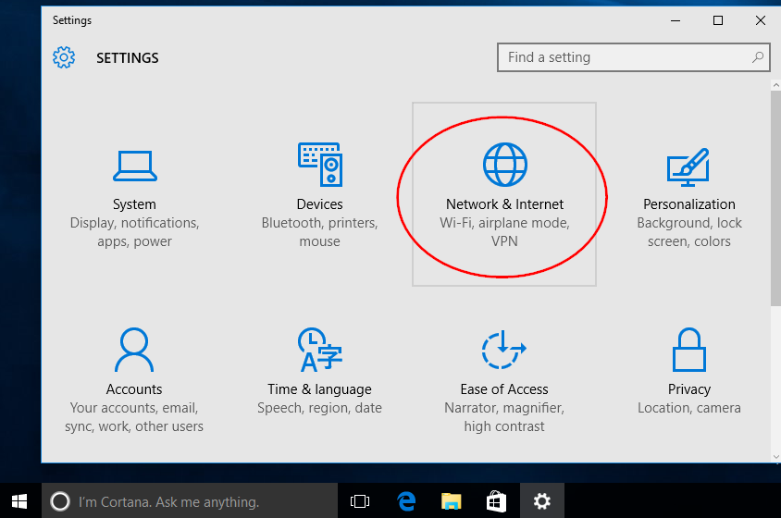

* + - 1. In the left pane select **Ethernet**, then click the **Change adapter options** link.

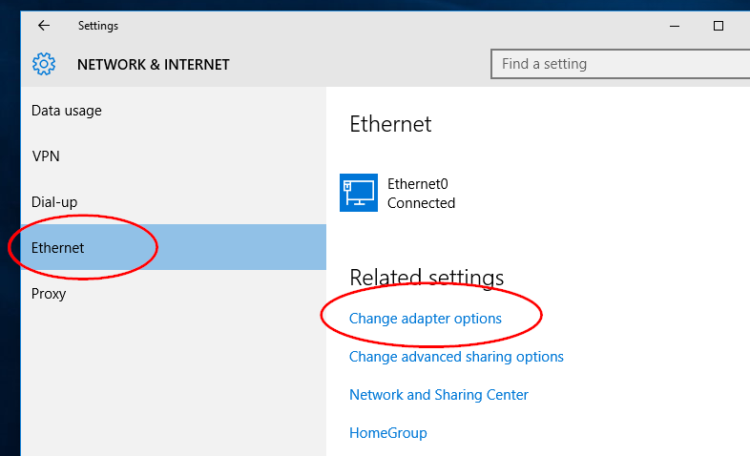

* + - 1. The Network Connections window displays the available network interfaces on the PC. In this example, right-click the **Ethernet0** interface and select **Properties**.

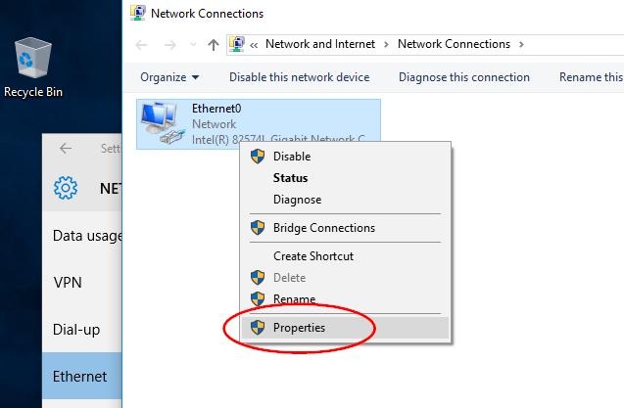

* + - 1. Select **Internet Protocol Version 4 (TCP/IPv4)** and then click **Properties**.

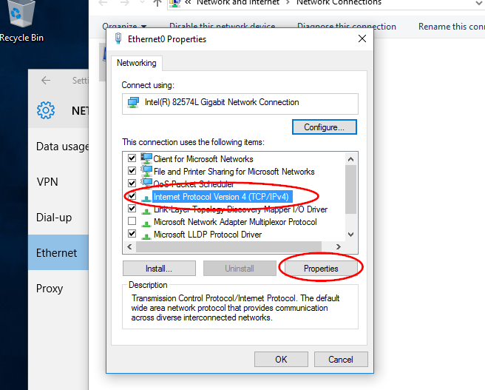

**Note**: You can also double-click **Internet Protocol Version 4 (TCP/IPv4**) to display the Properties window.

* + - 1. Select the **Obtain an IP address automatically**. Select the **Obtain DNS server address automatically**. Click **OK**.

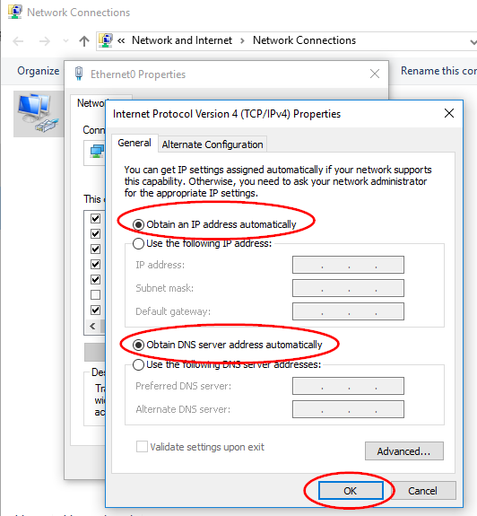

* + - 1. Before clicking **Close** on the Ethernet0 Properties window answer the following questions:

What is the name and model number of the NIC in the “Connect using:” field?

Realtek RTL8821CE 802.11ac PCIe Adapter

What are the first three items listed in the “This connection uses the following items:” field?

* 1. Client for Microsoft Networks
  2. VMWare Bridge Protocol
  3. File and Printer Sharing for Microsoft Networks
     + 1. Repeat the previous steps to configure network address settings on PC-B.
     1. Document PC-A networking address settings.
        1. Check the lights on the back of the NIC of PC-A. These lights will blink when there is network activity.
        2. Use **Command Prompt** to verify the PC settings and connectivity. From PC-A, right-click **Start** and select **Command Prompt**.
        3. At the prompt, enter **ipconfig /all** command to view IP configuration on PC-A.

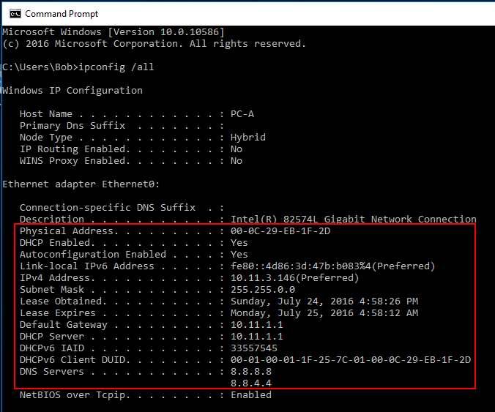

What is the IPv4 address of the computer?

192.168.31.120

What is the subnet mask of the computer?

255.255.255.0

What is the default gateway of the computer?

192.168.31.1

What are the DNS servers for the computer?

192.168.31.1

What is the MAC address (physical address) of the computer?

0C-96-E6-54-9D-61

Is DHCP enabled?

Yes

What is the IP address of the DHCP server?

192.168.31.1

On what date was the Lease Obtained?

Monday, May 25, 2020

On what date does the Lease Expire?

Tuesday, May 26, 2020

* + 1. Test the PC-A network interface TCP/IP stack.
       1. To verify that the TCP/IP protocol is functioning, pinging your loopback address (127.0.0.1). Enter the **ping 127.0.0.1** command at the prompt.

C:\Users\Bob> **ping 127.0.0.1**

* + - 1. You can also pingyour IP address. In this example, enter the **ping 72.163.4.161** or the **ping www.cisco.com** command at the prompt.

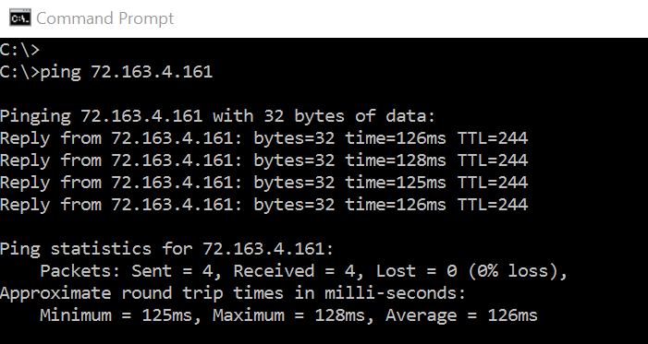

* + - 1. Record one of the replies from your ping command.

Reply from 127.0.0.1: bytes=32 time<1ms TTL=128

If the ping was not successful, ask your instructor for assistance.

* + 1. Document PC-B network address settings.
       1. Log in to PC-B using an account with administrative privileges.
       2. Verify that PC-B uses DHCP for the network address settings. Click **Start** > **Settings** > **Change adapter options**. Right-click the desired network adapter and select **Properties**. Double-click **Internet Protocol Version 4 (TCP/IPv4)** and ensure the **Obtain an IP address automatically** and the **Obtain DNS server address automatically** are selected. Click **OK** > **Close**.
       3. Open a command prompt window enter **ipconfig /all** at the prompt.

What is the IP address of the computer?

192.168.31.223

What is the subnet mask of the computer?

255.255.255.0

What is the default gateway of the computer?

192.168.31.1

What are the DNS servers for the computer?

192.168.31.1

What is the IP address of the DHCP server?

____________________________________________________________________________________

From PC-B, ping theIP address of PC-A*.* Was the ping successful?

**Note**: If you cannot ping the other PC, the firewall maybe blocking the ICMP echo.

To turn off the firewall, click **Start** > **Settings** > **Network & Internet** > **Ethernet** > **Windows Firewall** > Select **Turn Windows Firewall on or off**. Be sure to turn on the firewall when finished.

* + 1. Change PC-B’s network addressing from automatic to manual.
       1. Repeat Step 2 on PC-B, **Use the following IP address** and **Use the following DNS server address**.
       2. Enter in the IP address, subnet mask, default gateway and DNS server information that you recorded in the previous step. Click **OK** and **Close**.
       3. Open a command prompt window and ping the PC-B IP address you just configured. Was the ping successful?

____________________________________________________________________________________

* + 1. Test network connectivity with ICMP echo requests.
       1. From PC-B, ping theIP address of PC-A*.* Was the ping successful?
       2. From PC-A, ping, theIP address of PC-B. Was the ping successful?
    2. Return PC-B network address settings to autoconfigure with DHCP.

Return PC-Bs network address settings on Ethernet0 to **Obtain an IP address automatically** and **Obtain DNS server address automatically**. Click **OK** > **Close**.